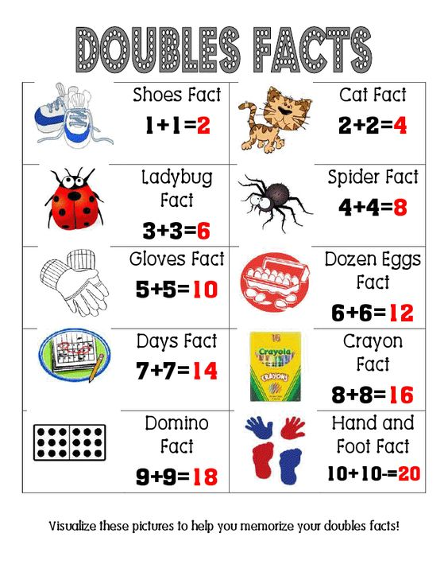

**Doubles**: When the numbers that you're adding are the same, remember to double it and think of a doubles picture.

Examples: 1+1=2    2+2=4    3+3=6   4+4=8    5+5=10  6+6=12 7+7=14     8+8=16     9+9=18    10+10=20

**Zero Addition**: When you add zero to a number, the number stays the same.

**Example:** 7+0=7 (the number stays the same)  
**Example**: 352+0=352 (the number stays the same)

**Doubles Plus 1:** When numbers are 1 apart on the number line, double it and add one.  
**Example**: 4+5= (think 4+4=8 plus 1 more =9)

**Counting On**: When you are adding 1, 2, or 3, start with the larger number and count on from there.

Addition Strategies

**Plus Ten**: When you add ten to a number the number in the tens spot goes up by 1.

Example: 10+42=52

Example: 67+10=77

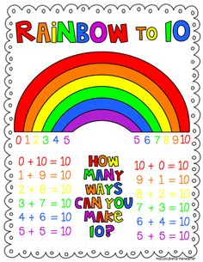

**Quick Ways to Identify Strategies: Z+: Zero Addition C on-Counting On DS: Doubles +10: Plus Ten**

**F10: Friendly Ten or Ten Partners D1: Doubles Plus 1 AN-Almost Neighbours**

**Friendly Ten/Ten Partners:** There are 6 pairs of numbers that go together to make 10.   
0+10=10   1+9=10   2+8=10   3+7=10   4+6=10   5+5=10     
**and the turnarounds:**

10+0=10 9+1=10 8+2=10 7+3=10 6+4=10 5+5=10

**Almost Neighbours:** When numbers are 2 apart on the number line go to the middle number and double it to get your answer.

Example: 6+8= (number in the middle is 7, 7+7=14 so 6+8=14)

**Counting Down:** If you are subtracting the numbers 1,2 or 3. Start with the bigger number and count down from that number. Example: 6-2= 4 (5.4)

**Doubles Subtraction:**When you subtract half of a number think of the doubles picture.

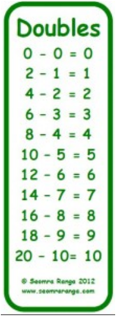

**A Number Minus Itself:** When the number you're subtracting is the same as the number you have, the answer is always zero.  
**Example**: 8-8=0 (the answer is always zero)

**Zero Subtraction:** When you are subtracting zero from a number, the number stays the same.  
Example: 12-0=12 (the number stays the same)

**Friendly 10 Subtraction:** When you subtract from the number ten, think of its ten partner.  
10-10=0  10-9=1  10-8=2    10-7=3    10- 6=4

10-5=5    10-4=6    10-3=7    10-2=8   10-1=9    10-0=10

**Count up**: When 2 numbers are close together on the number line, start with the smaller number and count up to get your answer. Example: 8-7=1 (start at 7 and count up to 8)

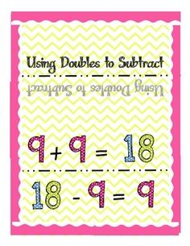

**Minus Ten**: When you subtract ten from a number the number in the tens spot goes down by 1.

Example: 52-10=42

**Quick Ways to Identify Strategies: Z-: Zero Subtraction N-: Number Minus Itself C up-Count Up DS: Doubles Subtraction CD: Counting Down -10: Minus Ten F10-: Friendly Ten Subtraction or Ten Partners**

Minus Ten: When you subtract ten from a number the number in the tens spot goes down by 1.

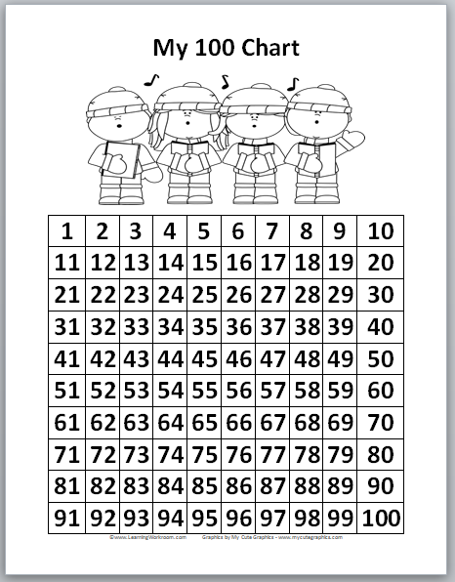

Example: 87-10=77

Example: 43-10=33